Intergovernmental Oceanographic |  | World
Commission of UNESCO |  | Meteorological Organization
 | 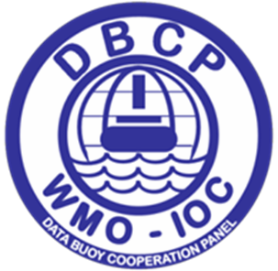 |  | 

DATA BUOY COOPERATION PANEL

GLOBAL DATA BUOY OBSERVATIONS
A DBCP Implementation Strategy

Sixteenth Edition
2018

Website only: http://www.wmo.int/pages/prog/amp/mmop/publications.html

DBCP Technical Document No. 16

2018

NOTES

WMO DISCLAIMER

© World Meteorological Organization, 2018

The right of publication in print, electronic and any other form and in any language is reserved by WMO. Short extracts from WMO publications may be reproduced without authorization, provided that the complete source is clearly indicated. Editorial correspondence and requests to publish, reproduce or translate this publication in part or in whole should be addressed to:

Chairperson, Publications Board
World Meteorological Organization (WMO)
7 bis, avenue de la Paix Tel.: +41 (0) 22 730 84 03
P.O. Box 2300 Fax: +41 (0) 22 730 80 40
CH-1211 Geneva 2, Switzerland E-mail: publications@wmo.int

NOTE

The designations employed in WMO publications and the presentation of material in this publication do not imply the expression of any opinion whatsoever on the part of WMO concerning the legal status of any country, territory, city or area, or of its authorities, or concerning the delimitation of its frontiers or boundaries.
Opinions expressed in WMO publications are those of the authors and do not necessarily reflect those of WMO. The mention of specific companies or products does not imply that they are endorsed or recommended by WMO in preference to others of a similar nature which are not mentioned or advertised.
This document (or report) is not an official publication of WMO and has not been subjected to its standard editorial procedures. The views expressed herein do not necessarily have the endorsement of the Organization.

IOC (of UNESCO) disclaimer

The designations employed and the presentation of material in this publication do not imply the expression of any opinion whatsoever on the part of the Secretariats of UNESCO and IOC concerning the legal status of any country or territory, or its authorities, or concerning the delimitation of the frontiers of any country or territory.

BibliographIc Reference

For bibliographic purposes this document should be cited as follows:
Global Data buoy Observations, a DBCP Implementation Strategy DBCP Technical Document No. 16, Sixteenth Edition, WMO-IOC 2018
(Original: English)

____________
FOREWORD

The Drifting Buoy Cooperation Panel (DBCP) was established in 1985, jointly by the World Meteorological Organization (WMO) and the Intergovernmental Oceanographic Commission (IOC) of UNESCO, as a means of enhancing cooperation, coordination and information exchange among the operators and users of drifting buoys, meteorological and oceanographic, research and operational. The aim was to improve both the quantity and quality of buoy data available on the Global Telecommunications System of WMO in support of the major programme requirements of the two Organizations. The Panel appointed a full-time Technical Coordinator in 1987, using funds provided voluntarily by panel member countries, and in 1992 its Terms of Reference were widened and its name changed to Data Buoy Cooperation Panel to reflect its work in co-coordinating all forms of ocean buoy deployments.

Since its establishment the Panel has achieved great success in achieving its initial objectives. At the same time, this period has also seen remarkable advances in buoy and communications technology, as well as greatly enhanced and expanded requirements for buoy data, in particular in support of global climate studies, ocean state estimation, and weather forecasting efforts.

In recognition of these new developments and expanded requirements, and in the context of the implementation plans and requirements of the Global Ocean Observing System (GOOS) and the Global Climate Observing System (GCOS), the Panel agreed in 1997 on the need for a DBCP Implementation Strategy, which would provide a framework for the Panel’s work, and at the same time enable it and its members to react appropriately to future developments. A draft strategy was prepared for the Panel by Mr David Meldrum, reviewed and revised at the panel session in 1998, and was published as this DBCP Technical Document, which has subsequently been reviewed and updated on an annual basis. The strategy document is also made available through the DBCP web-site.

PREFACE TO SIXTEENTH EDITION, October 2018.

It is intended that the Implementation Plan is a dynamic document that reflects the evolution of the DBCP's aims and aspirations within the rapidly changing environment of oceanography and marine meteorology. This edition particularly takes note of the seventeenth World Meteorological Congress decisions that are relevant to the Panel’s activities, including the development of the WMO Integrated Global Observing System (WIGOS) Pre-Operational Phase during the period 2016 to 2019.

[page left intentionally blank]

CONTENTS

CONTENTS v
RECORD OF CHANGES vii
1. INTRODUCTION 1
2. RATIONALE 1
2.1 The definition of requirements 2
3. ANALYSIS OF EXISTING DATA BUOY NETWORKS 4
3.1 Existing networks - current status 4
3.2 Existing networks - enhancements needed in support of the GOOS, GCOS, and the WWW 4
3.3 New observations urgently required 5
3.4 The observational challenge posed by 4-D assimilation schemes 6
3.5 Future research and development 6
3.6 Regional and national issues 7
3.7 Deployment opportunities 7
3.8 Coordination issues 7
4. DATA COLLECTION AND EXCHANGE 8
4.1 Argos 8
4.2 Iridium/Inmarsat 9
4.3 Moored buoys 9
4.4 Future developments 9
5. DATA MANAGEMENT 9
5.1 Quality control 9
5.2 Data archiving 10
5.3 Instrument Metadata 10
5.4 Data access policy 10
5.5 DBCP publicity 11
6. SUPPORTING ACTIVITIES 11
7. RESOURCE REQUIREMENTS 12
7.1 Human resources 12
7.2 Hardware and telecommunications 12
8. THE DBCP ROLE WITHIN JCOMM and its parent Organizations WMO and IOC 12
9. SUMMARY OF AIMS AND OBJECTIVES 15
10. REFERENCES 16
FIGURES 18
ANNEX A Acronyms 23
ANNEX B Observational requirements 25
ANNEX C Technical documents issued within the DBCP Series 26

RECORD OF CHANGES

Version No | Date | Change
A | Oct. 1997 | First draft
1.0 | Oct. 1998 | First release
2.0 | Oct. 2000 | Revised and updated to take account of JCOMM and developments in satellite communications
2.1 | Oct. 2001 | New references, graphics and textual changes
3.0 | Oct. 2002 | New section 3.4, updated Annexes E and F
4.0 | Oct. 2003 | Add paragraph 8.13, update Annex F
5.0 | Oct. 2004 | Updated paragraphs 2.1, 3.5, 3.8, 4.1, 4.2 and 7
6.0 | Oct. 2005 | Updated Intro, paragraphs 3.5, 3.8, 6.1, 6.2, 8.13
7.0 | Oct. 2007 | Substantial changes to include new initiatives for the Panel such as pilot projects, task teams, user workshops, training courses and other outreach activities
8.0 | Oct. 2008 | Consideration of WMO and IOC strategic planning; updated paragraphs 4.1, 4.2 and contact details
9.0 | Oct. 2010 | Consideration of the outcome of OceanOBS’09 and JCOMM-III, as well as the requirements of the developing GFCS, and new GCOS-IP 2010 update
10.0 | Oct. 2011 | Consideration of outcome of WMO 16th Congress and IOC 26th Assembly
11.0 | Oct. 2012 | Consideration of the outcome of JCOMM-IV
12.0 | Oct. 2013 | Consideration of the WIGOS Framework Implementation Plan and outcome of DBCP-29
13.0 | Oct. 2014 | Consideration of recent WIGOS developments and outcome of DBCP-30
14.0 | Oct. 2015 | Consideration of decisions of the seventeenth World Meteorological Congress
15.0 | Oct. 2016 | General updating throughout document
16.0 | Oct. 2018 | General updating throughout document

____________

GLOBAL DATA BUOY OBSERVATIONS - A DBCP IMPLEMENTATION STRATEGY

1. INTRODUCTION

Oceanographers and meteorologists have used both moored and satellite-tracked drifting buoys for over two decades in support of both research and operational programmes. With the exception of the Global Weather Experiment FGGE, early deployments were largely uncoordinated at an international or even national level. Cooperation between the meteorologists and the oceanographers was also practically non-existent, not only because of a lack of motivation stemming from different perceptions of the aims of drifter deployments, but also because no forum for dialogue existed. Some changes came about through the establishment of the Argos Joint Tariff Agreement (JTA), and its requirement for basic coordination of national plans, and through Argos User Conferences. However, it was not until the creation of the DBCP in response to WWW requirements for routine high quality observations from the world's oceans that positive steps were taken towards large-scale international cooperation in drifter deployment and data management.

Prior to the establishment of the DBCP, a European initiative (COST-43) was established involving the collaborative deployment of meteorological drifters in the north Atlantic and this became in due course the first regional action group - the European Group on Ocean Station (EGOS) - of the DBCP. It has become the model for subsequent action groups such as IABP, IPAB, IBPIO, ISABP, TIP, GDP, NPDBAP, and OceanSITES. The EGOS has now evolved into the E-SURFMAR (the Surface Marine programme of the Network of European Meteorological Services, EUMETNET) Data Buoy Expert Team.

All this has happened against a background of global climate change resulting from increasing concentrations of greenhouse gases. Such is the universal appreciation of the consequences of climate change that climate issues have moved to the forefront of the international political agenda. The GCOS and GOOS both owe their origins to this concern, and are responding directly to the needs, expressed in Agenda 21, by the IPCC, and in support of the UNFCCC, for ocean data to underpin the understanding and prediction of global climate and environmental change.

Much practical progress has been made from bringing together the oceanographic, meteorological and climate communities to define their observational requirements and the organizational structure that will assume responsibility for them, notably at the OceanObs 99¹, OceanObs’09², and JCOMM³ planning and following Session meetings. This implementation strategy, consistent with WMO and IOC Strategic Planning, takes note of these requirements and defines the DBCP role in the JCOMM structure.

2. RATIONALE

Neither the global programmes such as the GCOS, GOOS, WWW, nor indeed the DBCP action groups, are the funding bodies for observational networks. Instead, all commitments for the implementation of the networks that support the requirements of these global programmes are nationally funded. Therefore, the DBCP implementation strategy must attempt to reconcile the needs and aspirations of the global programmes with those of the data buoy operators and funders, and align with the WMO and IOC Strategic Planning. Ultimately, it is an objective of the implementation strategy to assist in the unlocking of sustained national funding in support of the wider regional and global needs, at the same time recognizing that the aims of the programme operators remain paramount.

2.1 The definition of requirements

There are four major met-ocean application areas that critically depend on accurate observations of met-ocean parameters: (a) Numerical Weather Prediction (NWP); (b) Sub-seasonal to longer predictions; (c) Met-Ocean Forecasts and Services (MOFS), including marine services and ocean mesoscale forecasting; and (d) climate applications and services.

WMO, in support of Earth Observation applications, studies and global coordination has developed the Observing Systems Capability Analysis and Review Tool (OSCAR) which constitutes a building block of WMO Integrated Global Observing System (WIGOS). The observational user requirements component of OSCAR (OSCAR/Requirements) provides a record of observational user requirements formulated by WMO and co-sponsored programmes: GCOS, GOOS, WCRP. User requirements are collated in a comprehensive, systematic and quantitative way in the WMO Observing Requirements database, which attempts to capture observational requirements to meet the needs of all WMO programmes. Refer to Annex B for detailed information.

Taking SST as an example, the WMO’s OSCAR Observational Requirements seeks observations at least every three hours over a 5 km to 250 km horizontal grid with accuracy better than 0.5 ºK and timeliness better than three hours for Global NWP. Ocean/climate application requirements expressed by the Ocean Observing Panel for Climate (OOPC) are an order of magnitude coarser in space and time, but at a level of accuracy an order of magnitude higher. In essence, this means that the density of any network deployed and maintained in support of weather forecasting will be more than adequate for climate monitoring, provided that the accuracy and stability of the sensors can be improved.

It should also be noted that OOPC calls for new sensors (e.g. for salinity) that are not yet operational. In this context, the OOPC suggest that any practical, achievable implementation plan be broken down into a number of elements running over differing time scales, viz the identification:

• of elements that are part of existing operational∗ systems;

• of elements to be added to constitute the initial observing system (either enhancements to existing operational systems or parts of existing research observing systems ready for transition to operational status);

• specification of observations not presently readily obtainable that are urgently required and should be added as enhancements to the initial system at the earliest feasible time; and

• of future research and development likely to be needed for further expansion of the system.

These basic requirements have been endorsed and further developed by other bodies, notably by GCOS and the UNFCCC⁵. Climate aspects are detailed in the Implementation Plan for the Global Observing System for Climate in Support of the UNFCCC (GCOS-92, October 2004)⁶ which was updated in 2010 (GCOS-138)⁷. While the exact composition of the desired network is under continuous review, an array of 1,250 drifters has achieved wide acceptance, and was set as a target within the JCOMM Observations Programme Area strategic plan⁸. This target has now been refined in terms of maintaining a global 5 degree x 5 degree array of drifting buoys (excluding marginal seas, high latitudes and those areas with high drifter ‘death’ rates). This requires smart and coordinated deployment strategies.

As part of the WMO Commission for Basic Systems (CBS) Rolling Review of Requirements (RRR) process, a Statement of Guidance (SoG) for Ocean Applications was developed to specifically address the requirements for met-ocean forecasts and services. These requirements had not been properly considered until then. The SoG provides for a gap analysis and includes recommendations to address identified deficiencies to meet the user needs. The Panel will strive to address those deficiencies.

OceanObs’09 (21-25 September 2009, Venice Italy) was organized to celebrate progress in implementing the existing initial ocean observing system, realizing societal benefits from it and highlighting its potential; and to develop a process for building consensus for sustaining and evolving systematic and routine global ocean observations over the next 10 years in support of further societal benefits. The Framework for Ocean Observing (FOO)⁹ and the new structure of GOOS (Res. IOC XXVI-8), direct outcomes of the OceanObs’09 initiatives, have developed methodologies for building ocean observation systems. The Panel will address these recommendations from the FOO and OceanObs’09, in particular those from the Community White Papers², that directly relate to buoy observations. The agreed Conference Statement of OceanObs’09 in particular:

- Calls on nations and governments to fully implement by 2015 the initial global ocean observing system envisioned at OceanObs’99;

- Calls on nations and governments to commit to the implementation of systematic biogeochemical and biological observations, and to extend the international coordination of observations, archiving and dissemination to regional and coastal ecosystems, guided by the outcomes of OceanObs’09;

- Invites governments and organizations to embrace a Framework for planning and moving forward with an enhanced global sustained ocean observing system over the next decade, integrating new physical, biogeochemical, biological observations while sustaining present observations. (Framework for Ocean Observing (FOO)⁹));

- Urges the ocean observing community to increase our efforts to achieve the needed level of timely data access, sensor readiness and standards, best practices, metadata, uncertainty estimates, and integrated data set availability, and;

- Asks governments, organizations, and the ocean observing community to increase their efforts in capacity-building and education.

The Panel is also addressing the priority activities for this JCOMM inter-sessional period as decided at the fourth JCOMM Session (JCOMM-IV, Yeosu, Republic of Korea, 23-31 May 2012) for the Observations Programme Area (OPA) as described below, in no particular order:

- contribute to WIGOS Implementation (see section 8 below);

- proactively engage and establish dialogue with requirements setters and writers of implementation plans (such as OOPC, the WMO RRR, and the GFCS) to set realistic priorities for the future composite ocean observing system, establish practical ways of moving forward, and together seek routes for funding;

- recruit additional Members / Member States, institutions and agencies, in a way that allows their activities to progress on their own priorities and to contribute to the global observing effort;

- identify other ocean observing communities (e.g. ocean glider operators) and marine industry fora (e.g. the World Ocean Council) that might be recruited to extend the scope and capability of ocean observation;

- develop synergies between observing systems to exploit the potential of joint deployment opportunities, and to foster a common approach to sensor development and best practices;

- develop pilot projects as a means towards the rolling out of the new platforms, sensors and technologies that will in due course become routine components of the observing network;

- continue capacity development activities, including training workshops, that will assist developing countries to better use ocean products and to participate more fully in the global observing effort;

- encourage identification and implementation of observing standards and best practices, with particular focus on developing countries, including through encouraging JCOMM members to offer new Regional Marine Instrumentation Centre (RMIC) facilities; and

- continue to document institutional data and meta-data management practices for each component of the observing system to advance consistent, climate-quality, seamless data delivery both in near real time and delayed mode.

3. ANALYSIS OF EXISTING DATA BUOY NETWORKS

3.1 Existing networks - current status

In general, most current operational buoy networks fall within the scope of one or other of the existing DBCP action groups. Figure 1 indicates the areas of responsibility of each action group. Two of them are global: the Global Drifter Programme, which contributes over 80% of the global drifter array, and OceanSITES. For the global drifter array the deployments are increasingly of SVP-B drifters, which combine quantifiable current-following characteristics with reliable measurements of atmospheric pressure and SST. At present, over 1,300 drifters report their data via the GTS (Figure 2); nearly 60% of these report atmospheric pressure. Regular re-seeding is needed to maintain observational density, particularly in dynamic areas such as the tropical oceans. The action groups are the key to implementing and maintaining deployments in all ocean basins. Operating Principles of the DBCP gives an example of the operating principles for an action group.

Moored buoys are deployed, operated, and maintained by various National Meteorological and Hydrological Services (NMHSs). Therefore there is a wide range of different moored buoy designs operated with hulls that vary in sizes (2 m to 12 m) and shapes (e.g. discus, boat shape, torus, tower) depending on the expected sea state conditions, water depth and the type of measurements required. Most measure the basic marine meteorological variables (sea level pressure, air temperature, relative humidity, sea surface temperature, wind vector and significant wave height). Most are deployed in coastal areas but a few are also deployed in the high seas. Capabilities vary from country to country, with most (if not all) buoys measuring meteorological variables and some networks also measuring oceanographic variables. Many of these networks have been in place for 20 years or so and deliver data for weather and ocean state prediction, as well as providing time-series for marine climate studies, in particular for wave climate. As well as the various national met-ocean moored buoy networks this category includes the TAO, PIRATA RAMA and NIOT (India) arrays of tropical moored buoys, the world-wide OceanSITES network of long-term open-ocean reference stations and the tsunami buoys . Figure 3 shows the distribution of the 400 or so moored buoys presently in operation.

3.2 Existing networks - enhancements needed in support of the GOOS, GCOS, and the WWW

Although the statistics for data availability collected by the various operational and archiving centres do not always agree, and despite the completion of the global drifter array in September 2005, it is clear that the existing networks do not achieve the required observational density in a number of areas, viz the:

• global oceans (waves);

• tropical oceans (P, waves);

• tropical Indian Ocean (wind, waves);

• polar regions (SST, P);

• North Pacific Ocean (SST, P);

• North East Tropical Pacific Ocean (SST, P);

• Arabian Sea (SST, P);

• Gulf of Guinea (SST, P); and

• Southern Ocean south of 40 S (SST, P, waves).

The JCOMM Observations Coordination Group (OCG) has made recommendations to achieve better global coverage. Deployment and re-seeding strategies are required to optimize the expenditure of available resources, and which allow accurate and credible prediction of future resource requirements, and their relation to declared objectives. In an effort to better maximize drifter deployments, the Global Drifter Program has created regional deployment maps that assign values to each of the drifters within the drifter array, as shown in Figure 4. Each drifter deployment value is determined by the number of operational sensors, drogue presence, drifter age, and projected spatial coverage in conjunction with nearby drifters. Assessing these values on a regional scale will allow program coordinators to better maximize their deployment efforts and improve the spatial coverage of drifter data.

3.3 New observations urgently required

Surface atmospheric pressure and wind. Equatorial areas, where atmospheric pressure fluctuations are typically weak, would benefit from a greatly increased density of wind observations but requirements for accurate in situ pressure measurements from these regions have also been expressed by NWP at a resolution similar to the global drifter array (i.e. 500 km x 500 km). Spatial surface air pressure coverage is presently marginal for marine services applications. Mean sea level pressure is vital to detect and monitor atmospheric phenomena over the oceans (e.g. tropical cyclones) that significantly constrain shipping. Even very isolated stations may play an important role in synoptic forecasting, especially when they point out differences with NWP model outputs. Although the proportion of drifters measuring pressure has increased to over 50%, this is still short of the target (GCOS-138⁷) to equip all drifters with pressure sensors. The equatorial Pacific is being adequately sampled by the moored TAO and TRITON arrays, the PIRATA programme is addressing the sparsity of observations in the tropical Atlantic and the RAMA array in the Indian Ocean is beginning to address needs there. The implementation of the eastern portion of the moored buoy array will proceed once piracy issues have been addressed. The WMO Seventeenth Congress (Cg-17, Geneva, Switzerland, 25 May – 12 June 2015) approved Recommendation 18 (CBS-Ext.(2014)) – Support of Members to the implementation plan of the marine meteorological and oceanographic observing system in support of NWP and requested the Secretary-General to invite Members to contribute to the DBCP Implementation Strategy, and commit appropriate resources to the barometer drifter, and the tropical moored buoy arrays; to invite National Meteorological and Hydrological Services (NMHSs) to collaborate with partner organizations, and use the opportunity of the DBCP barometer drifter upgrade scheme; and to bring this recommendation to the attention of Members. In particular, Cg-17 requested Members to fund and install barometers on all newly deployed drifters.

Wave observations. In situ measurements are currently very sparse in the open ocean. The vast majority of existing wave measurements are made in the coastal margins of North America and Western Europe, with a huge data void in most of the rest of the global ocean, while other existing observational systems have reasonable coverage in these areas. The JCOMM Expert Team on Wind Waves and Storm Surges (ETWS, now Expert Team on Waves and Coastal Hazards Forecasting Systems – ETWCH) has called for additional wave measurements comprising, at a minimum, significant wave height, peak period and 1-D spectra, hourly in real-time, for assimilation into coupled atmosphere-ocean wave models for real-time forecasting activities, and subsequent verification. These are required for Maritime Safety Services, calibration/validation of satellite wave sensors, the description of the ocean wave climate and its variability on seasonal to decadal time scales, and the role of waves in the coupled ocean-atmosphere system, and their inclusion in weather and climate models. Satellite bias correction validation requirement is for average 1000 km spacing with minimum 10%/25cm accuracy for wave height and 1 second for wave period. Considering the lack of wave data, the DBCP is inviting buoy operators and Panel Members to increase wave measurements, particularly from open ocean areas in the Southern Ocean and the tropics. The Panel’s Task Team on Wave Measurement (TT-WM) will continue to explore technologies, report on evaluation results, and support ongoing development, particularly with respect to wave measurement from drifting buoys.

Sea level observations. Tsunami and storm surge-prone basins (e.g. Bay of Bengal, Gulf of Mexico and Pacific Islands) require higher density of sea level observations accompanied by observations of atmospheric pressure, and if possible winds and other environmental parameters. The International Tsunameter Partnership (ITP), now an Action Group of the DBCP, is supporting the establishment, effectiveness and on-going viability and enhancement of tsunami detection and warning systems using deep ocean monitoring stations (tsunameters).

3.4 The observational challenge posed by 4-D assimilation schemes

Recent studies using models that allow assimilation of non-synoptic hour data have demonstrated the positive impact of such data. In particular, the inclusion of hourly extra-tropical buoy data was found to significantly improve forecast quality, particularly in the southern hemisphere. Non-synoptic and hourly data are not always routinely reported on GTS by all buoys. In those cases little change would be needed to the current practice to allow these additional data to be made available to forecasters. Further, with the use of BUFR to disseminate data on GTS it will be possible to report sub-hourly buoy data.

3.5 Future research and development

In addition to the development and proving of accurate and reliable wind and wave sensors on drifting buoys, OOPC have stated a requirement for ocean surface salinity and rainfall measurements. Relatively few drifters currently possess this capability, and it is expected to become an area for further research and development. In situ salinity measurements from drifters, moored buoys and profiling floats will be of great value in ground-truthing the sensors and algorithms for salinity determination by satellites such as SMOS launched in 2009 and Aquarius/SAC-D (2011-2015).

The Panel will also support other technology developments, e.g. the use of adaptive sampling (‘smart buoys’) to increase the impact and cost effectiveness of data buoy observations. The Panel also recognizes the need for research to quantify the impact of buoy observations on NWP and established a pilot project to conduct such studies. The results of the pilot project have now been published, with a recommendation to add barometers to all drifters and also deploy them at low latitudes. The pilot project, having completed its work, was closed at DBCP-31. Work is continuing to use existing current climatologies and the like to develop deployment and re-seeding strategies that optimize these impacts within defined logistical and financial constraints.

The Panel organizes an annual Scientific and Technical Workshop where such research and development can be presented and discussed

NDBC, NIOT-India JAMSTEC Japan have developed video/photo telemetry system from Buoys

3.6 Regional and national issues

It should not be forgotten that data buoy deployments continue to be made in support of both operational and research programmes, which do not fall within the sphere of influence of any of the DBCP action groups. Efforts by the DBCP and the action groups will continue, to involve these buoy operators in the work of the Panel, and to ensure where appropriate, that their buoy data are made available to the wider community, in near real-time if possible.

Vandalism of Buoys is a global problem being addressed by a working group and is being reported in IOC and WMO congress. UN GA has urged member countries to safeguard these buoys. Periodic awareness meetings and technological advancement are being undertaken. Costs involved to refurbish/re-establish buoys are very expensive with loss of valuable data in the intervening period.

3.7 Deployment opportunities

The deployment and re-seeding of a large network of drifting buoys poses a huge logistical problem. To date, deployments have largely been accomplished opportunistically using volunteer ships and aircraft. This system is showing increasing signs of strain, and the DBCP will actively pursue additional strategies, recognizing that the issue of funding and associated logistical effort will have to addressed. The Panel, with SOT and Argo have supported a Ship Logistics Coordinator to work as part of the JCOMM in situ Observations Programme Support Centre (JCOMMOPS).

3.8 Coordination issues

Within the above context, the regional action groups are best placed to identify the precise needs in their particular areas of responsibility and to obtain the resources required.
The Panel recognizes the autonomy of these groups and does not seek to impose any additional level of management or control. The Panel will also actively pursue the creation of new action groups to take care of issues associated with particular platform types, or other non-regional issues such as tsunami detection and warning.

There are areas, however, where the Panel is best placed to advise on overall methodology and policy; such areas include:

a) Co-ordination of deployments in areas not covered by the Action Groups or which involve several Action Groups.

Such areas presently include the Southern Ocean and the Black Sea. Unless there is a need to establish DBCP Action Groups for those areas, it is proposed to include such buoy programmes directly within the DBCP implementation strategy and to discuss important co-ordination and implementation issues at Panel sessions where all DBCP Action Groups are normally represented. During intersessional periods, co-ordination can take place through direct exchange between buoy operators and through the Technical Coordinator as focal point who can set up specific mailing lists for this purpose. In the event that such programmes reach a sufficiently high level of co-ordination, and if the buoy operators express the need, it could be proposed to establish new DBCP Action Groups.

b) Real-time data quality control,

c) Data management,

d) Provision of instrumental metadata for climate studies,

e) Other co-ordination issues such as the negotiation of bulk purchase rates for drifter hardware and communications costs.

The role of the Panel and its Technical Coordinator within the JCOMM structure is discussed in section 8.

4. DATA COLLECTION AND EXCHANGE

4.1 Argos

Until recently, the majority of open ocean data buoys used the Argos satellite system for location and data transmission. Argos centres in France and the USA process telemetry datasets stored on board the NOAA satellites that carry Argos. Data are quality controlled and inserted on to the GTS for use by NWP and climate modellers, and for archival by the responsible data centres, if authorised by the buoy operator. Argos data timeliness, vital for weather forecasting, can be improved by using LUTs to access buoy data rebroadcast by the satellites in real-time. The operators of the Argos system have been attentive to the need for faster data turn round times, and have taken steps to increase the amount of LUT data that are processed by the two main centres.

An agreed share of the operating costs of the two centres (approximately €6.4 million in 2006 out of a total of €12.2 million) is recovered under the terms of the Argos JTA, under which all non-commercial usage of the system (of which data buoy operators account for roughly 50%) is charged out to users at an agreed and negotiated rate. The Argos costs associated with a drifting buoy programme are significant and can be higher (except for large programmes) than the actual buoy procurement costs over the lifetime of a drifter
The DBCP will negotiate actively to achieve the best possible terms for data buoy users.

Recent developments with Argos are the implementation of the two-way Argos 3, and increasing the number of ground stations which are addressing timeliness issues. In addition, they have established a protocol for the assimilation of data from third party communications (e.g. Iridium) providers into their own GTS processing chain.

4.2 Iridium/Inmarsat

More recently, other satellite service providers, notably Iridium, have entered the marketplace, A successful evaluation of the Iridium communications system was conducted through a dedicated Pilot Project and presently around 37% of drifting buoys now use Iridium to transmit their data. Iridium, being a constellation of 66 Low Earth Orbit satellites provides global coverage, with the dual benefits of being lower cost (than Argos) and with more timely data delivery, which is of particular benefit for NWP. Iridium transmission modes include short burst data delivery for low data rates and RUDICS (Router-Based Unrestricted Digital Internetworking Connectivity Solutions) for high date rates.

4.3 Moored buoys

For moored buoys a variety of different satellite systems are used, including geostationary satellites (e.g. Meteosat, GOES, Insat), Argos on the polar orbiters and commercial systems such as Iridium. As with drifting buoys, many moored buoy operators are transitioning to Iridium given its timeliness and facility for two-way communications.

Inmarsat is used for buoy data telemetry by India, China and Malaysia and is Indian Government approved satellite telemetry. Inmarsat telemetry involves relaying through Land Earth Stations [LES], which also contributes to the high latency and power consumption is 8 to 10 times more compared to Iridium.

4.4 Future developments

Many new mobile satellite services are at the planning or pre-operational stage (see http://wo.jcommops.org/cgi-bin/WebObjects/JCOMMOPS.woa/wa/menu?abbrev=J_SAT_COMM), and these are attractive to buoy operators, both from the cost perspective and from the increased operational flexibility (e.g. two-way communication) that they potentially offer. However, many of these new systems may not reach full operational capability, nor will buoy operators ever achieve more than minority user status. Systems such as Iridium and Orbcomm, which have launched services, encountered severe financial difficulties before becoming commercially viable.

The Panel will, in this context, act as a focus for the exchange of practical information on the performance of the various systems, and will continue to be active in sponsoring evaluation trials and pilot projects of new equipment and systems as they become available. As with Argos, the Panel will seek to negotiate where possible the best terms for data buoy users of these systems.

JCOMM has established an International Forum of Users of Satellite Data Telecommunication Systems (Satcom Forum) covering a wide user basis, and to address remote data communication requirements - including tariff negotiations as needed - for automatic environmental observing systems coordinated through WMO and IOC and partner organizations.

5. DATA MANAGEMENT

5.1 Quality control

Quality control procedures, jointly developed and implemented by the DBCP and the operators of the Argos system, currently ensure that surface drifter observations are validated in real-time before insertion on to the GTS (see DBCP Technical Document No. 2).

For moored buoys, the data are quality controlled by the operating agencies, where NDBC Technical Document 09-02 - Handbook of Automated Data Quality Control Checks and Procedures describes the types of checks that may be made, although these are not standardized across the various national moored buoy networks. Sub-surface data (e.g. from the TAO array) are further quality controlled by NOAA / NDBC.

A number of other bodies (ECMWF, Meteo-France, UK Met Office) provide real-time data monitoring and others (GDC, ISDM, etc.) contribute to an active off-line assessment of data quality. A well-defined feedback mechanism ensures that any interventions arising from this quality control (e.g. modifications to individual sensor transfer functions) are implemented into the real-time data processing chain in a coordinated and auditable fashion.

The Panel encourages the operators of other observing systems to benefit from its experience in this regard, with a view to avoiding the many quality pitfalls that beset the acceptance of early drifting buoy data by the operational community.

5.2 Data archiving

The trial JCOMM Global Data Assembly Centres (GDACs) for drifting buoys are Météo-France (formerly the Specialised Oceanographic Centre (SOC) for drifting buoy data) and MEDS (formerly the IODE Responsible National Oceanographic Data Centres (RNODC) for Drifting Buoys). Drifter data inserted on the GTS are routinely archived by MEDS. The DAC archives all data from the GDP, and any other drifter data that are made available to it. The Panel and its action groups will actively encourage all buoy operators to forward their data to one or other of these responsible global archives. For moored buoy data there is no dedicated GDAC, as there is for drifter data. All drifter and moored buoy data should ultimately be incorporated into ICOADS (the International Comprehensive Ocean- Atmosphere Data Set) which is the primary dataset used for marine climate research.

5.3 Instrument Metadata

There has been an increasing demand for instrument metadata in recent years to serve a number of applications and climate studies in particular. The DBCP has established its own drifter metadata collection system at JCOMMOPS and is participating in the overall JCOMM efforts to integrate the management of instrument/platform metadata from ocean observation platforms, including the provision of buoy metadata to the WMO-IOC Centres for Marine Meteorological and Oceanographic Climate Data (CMOCs)∗ and the WMO Integrated Global Observing System (WIGOS) metadata system OSCAR database. Work has also been carried out under the Panel to define and collect the necessary metadata for moored buoy systems and to make these data available to users via the JCOMMOPS web-site and OSCAR.

5.4 Data access policy

At present, all of the archiving agencies and many of the operational and research bodies make provision for the release of buoy data to scientific and other customers. In particular, many data are available via the World-Wide Web, either in the form of trackplots or as datasets. In many cases, the policies relating to the release and use of these data are not immediately clear. The Panel is seeking clarification from these agencies, and from its action groups, with a view to developing a coordinated data access policy for buoy data within the letter and the spirit of the WMO and IOC data exchange policies. These policies are defined in WMO Congress Resolution 40 (Cg-12), WMO Policy and practice for the exchange of meteorological and related data and products including guidelines on relationships in commercial meteorological activities, Resolution 60 (Cg-17), WMO Policy for the international exchange of climate data and products to support the implementation of the Global Framework for Climate Services (GFCS), and IOC Assembly Resolution XXII-6 for oceanographic data exchange policy.

5.5 DBCP publicity

Many suggestions have been made over the years regarding ways of publicizing the DBCP and its activities. The DBCP website is now the de facto entry point for current information about the DBCP and its action groups. The Panel is taking steps to ensure that resources and information are available to allow this website to be developed and updated as required.

6. SUPPORTING ACTIVITIES

6.1 User workshops

The Panel recognizes the enormous importance of engaging with the many communities that impinge upon its activities, from the research organizations developing new sensors to the manufacturers that provide the products on which buoy operators depend and the user groups, both operational and research that depend on data buoy observations. To this end, it will from time to time organize, or participate in, workshops that draw together these communities in addressing key common issues.

  - Capacity-Building

In recognition of the vast experience that exists amongst its members, the wish for developing nations to become engaged in data buoy activities, and the benefits that would accrue to the Panel from developing collaborative deployment arrangements with these countries, the Panel will actively create and deliver training courses targeted at these regions. The Panel will coordinate Capacity-building activities with the IOC Capacity Development Strategy¹¹ and WMO programmes, where applicable. Materials developed for these courses will be added to the repositories of educational resources on websites such as Ocean Teacher (http://ioc.unesco.org/oceanteacher).

  - Task Teams and Pilot Projects

Experience has shown that specific technical or organizational issues facing the Panel are often best attacked by a small team of experts, working during inter-sessional periods, and that their deliberations may lead to coordinated evaluation activities. The Panel will continue to foster the creation of such Task Teams and Pilot Projects as an efficient way of meeting its objectives within resource constraints.

  - Other outreach activities

The Panel is cited as a model of a practical coordination group, which has managed the transition of an observing system from the research laboratory to the operational arena. Other bodies frequently come to the Panel for advice and assistance, and the Panel will continue to offer every possible support to such groups, in recognition that its activities are but a component of a much wider effort within the framework of the JCOMM Observations Programme Area.

7. RESOURCE REQUIREMENTS

7.1 Human resources

Most of the success of the Panel to date in implementing its objectives is entirely due to the efforts made on its behalf by its Technical Coordinator, and by the support afforded to him/her by the buoy operators and other agencies. The Panel will build on this success by actively seeking adequate and secure resources to ensure the continued employment of its Technical Coordinator. In this context, the Panel will make every effort to act as a responsible employer and will make every effort to ensure that sufficient and stable funding is in place to meet its obligations in this regard.

In 2013, in recognition of buoy programme implementation activities undertaken in Brest, and the need to reinforce synergies and collaborations with the Argo and SOT programmes which also rely on institutions based in Best, the Panel made the strategic decision to move the Technical Coordinator’s position to Brest, France.

7.2 Hardware and telecommunications

The JCOMM strategic implementation workplan calls for maintaining a network of drifters providing global 5º x 5° coverage (about 1,250 drifters) in the global oceans outside of high latitudes, all equipped with barometers (although only around 55% of drifters currently carry barometers). This presently represents a hardware investment of US$ 4 million.

The maintenance of the drifter network presents formidable re-seeding and enhancement challenges if its value is to be fully realised. Re-seeding of networks to cover buoy mortality and dispersion will require a further annual hardware commitment of 650 SVP-B (US$ 2 million at current cost levels) if present drifter lifetimes and trajectories are maintained. Technical issues that result in early buoy mortality will require an even greater number of drifters to be deployed.

The increasing use of iridium (about 37% at present) will contribute to reduced telecommunications costs for some drifter programmes. If this trend continues, there may be on impact on how other telecommunications providers structure their pricing.

In recognition of the economies of scale that will flow from global annual procurements of this size, the Panel and its action groups will seek negotiations with the drifter manufacturers and the communications service providers to establish economical prices that will then be available to individual buoy operators.

8. THE DBCP ROLE WITHIN JCOMM and its parent Organizations WMO and IOC

The structure of JCOMM is as shown in Figure 5. JCOMM comprises 3 Programme Areas: Services & Forecasting, Observations and Data Management. DBCP sits within the Observations Programme Area (OPA). At the top level of the OPA is the Observations Coordination Group (OCG) that oversees the OPA's activities and comprises representatives from the component activities and related programmes. Membership of this group includes the Chairperson and Technical Coordinator of the DBCP. The Terms of Reference of the DBCP and its Technical Coordinator are given in Operating Principles of the DBCP.

The DBCP Implementation Strategy is consistent with the JCOMM Observations Programme Area Implementation Plan⁸. In practical terms, the DBCP Technical Coordinator works alongside the coordinators of other observing systems to implement a common approach to deployment strategy, data management and quality control, and to ensure the most efficient use of deployment opportunities.

As part of its contribution to the WMO Strategic Plan for 2012 to 2015, and particularly to Expected Result 4*, the DBCP is committed to assisting in the development of the WIGOS, facilitating buoy data exchange through the WMO Information System (WIS). From that perspective, the Panel is committed to follow the legacy recommendations from the Pilot Project for the integration of marine and other appropriate observations into the GOS (or WIGOS Pilot Project for JCOMM). This implies the following actions by the Panel:

- Integrating DBCP Best Practices and Standards into the WIGOS. This will be achieved through: (i) contributing to the development of WIGOS Best Practices and Standards; (ii) implementing those WIGOS agreed upon Best Practices and standards; and (iii) contributing to the development of specialized and / or Regional Marine Instrument Centres;

- Promoting the distribution of the data in real-time through the WMO Information System (WIS);

- Promoting the provision of the delayed-mode drifter data to the two drifter GDACs and encouraging them to develop interoperability arrangements with the WIS;

- Promoting the collection and exchange of buoy platform / instrument metadata and their provision through the Marine Climate Data System (MCDS) and WIGOS.

The Panel is also committed to responding to the observational data requirements of the developing Global Framework for Climate Services (GFCS). From that perspective, the Panel will be working towards the sustainability of the drifting and moored buoy networks already contributing to the GCOS.

The Panel agrees to utilize the Framework for Ocean Observing as a guide to identify ocean observation requirements and priorities, facilitate drifters and moored buoys deployment and maintenance, and enhance oceanographic data sharing and information exchange. As a contributing network to GOOS, the Panel continuously makes a contribution to an integrated and sustainable global ocean observing system, in particular supporting GOOS Strategy 2030 and Implementation Plan.

In addition, the Panel agrees that operational and research observing networks in Polar Regions should be integrated within the framework of the WMO Integrated Observing System (WIGOS) and the WMO Information System (WIS), be enhanced to include cryosphere related variables recognizing that a major contribution to this objective will be through development of the Global Cryosphere Watch (GCW). The Panel is committed to contribute to the implementation phase of the GCW (2012-2019) by deploying automated observing platforms on and under the sea and ice, in order to meet the needs of NWP, hydrological services, climate studies and research programmes.

Following the adoption of the WIGOS framework Implementation Plan (WIP) (see website∗) by the Sixty-Fifth Session of the WMO Executive Council (Geneva, Switzerland, 15-23 May 2013), the Panel agreed on its response to the Key Activity Areas of the WIP as described in Table 1 below.

WIP  KAA No. | WIP Key Activity Area (KAA) | Proposed DBCP response
1 | Management of WIGOS implementation | DBCP Executive Board and Technical Coordinator to provide DBCP input to the Inter Commission Group on WIGOS (ICG-WIGOS) and its Task Teams through the JCOMM representatives in those groups.
2 | Collaboration with the WMO co-sponsored observing systems & international partner organizations & programmes | Strong collaboration established between WMO and IOC for the DBCP since 1985
3 | Design, planning & optimized evolution | WMO Rolling Review of Requirements considered at yearly DBCP Session to adjust implementation strategy  DBCP Contribution to JCOMM OPA Implementation Goals for the surface drifters (1250 units) and the tropical moored buoys (125 units)
4 | Observing System operation & maintenance | DBCP to continue contributing to JCOMMOPS  DBCP to contribute to the Satcom Forum  DBCP to continue pilot activities (PP-HRSST, PP-WET)
5 | Quality Management | Keeping DBCP TD No. 37 up to date (Guide to buoy data QC tests to perform in real time by a GTS data processing centre)  Continue operating the DBCP QC guidelines  Promoting quality information feedback mechanisms between ocean in situ & satellite observation communities through the DBCP Pilot Project on HRSST  DBCP Task Team on Instrument Best Practices and Drifter Technology Development (TT-IBP) to continue evaluating performance of buoy data
6 | Standardization, system interoperability & data compatibility | To consider migrating some of the DBCP ongoing activities of the DBCP Implementation Strategy to the WIGOS Technical Regulations
7 | WIGOS Operational Information Resource (WIR∗) | Buoy operators to make sure that buoy metadata are made available via JCOMMOPS on a routine basis.
8 | Data & metadata management, delivery & archival | Buoy operators to make sure that buoy metadata are made available via JCOMMOPS on a routine basis.
9 | Capacity development | DBCP to continue supporting Capacity Building activities
10 | Communications & outreach | DBCP to continue to be informed about WIGOS implementation at regular DBCP sessions.

Table 1: WIGOS Framework Implementation Plan (WIP) Key Activity Areas, and the DBCP response.

The seventeenth World Meteorological Congress (Cg-17, Geneva, Switzerland, 25 May – 12 June 2015) decided that the development of WIGOS will continue during its Pre-Operational Phase in the seventeenth financial period (2016-2019) building upon and adding to those key building blocks of the WIGOS Framework that have already been implemented, while shifting the emphasis from the global level toward implementation activities at the regional and national levels. The goal is to have Members and their partners benefit from a fully operational system from 2020 per Resolution 23 (Cg-17) – Pre-operational Phase of the WIGOS.

The DBCP is taking note of the highest priority areas of the pre-operational phase of WIGOS i.e. (i) national WIGOS implementation; (ii) WIGOS Regulatory Material complemented with necessary guidance material to assist Members with the implementation of the WIGOS technical regulations; (iii) further development of the WIGOS Information Resource (WIR), with special emphasis on the operational deployment of the OSCAR database (http://oscar.wmo.int); (iv) development and implementation of the WIGOS Data Quality Monitoring System; and (v) concept development and initial establishment of Regional WIGOS Centres). The JCOMM in situ Observations Programme Support Centre (JCOMMOPS) will contribute to the development of the WIGOS Data Quality Monitoring System for the met-ocean observing systems part of that system (action; JCOMMOPS; 2019). Panel members are invited to consider how some data buoy related activities could be undertaken as part of the developing Regional WIGOS Centres.

9. SUMMARY OF AIMS AND OBJECTIVES

  - The Panel will encourage its Members to assist, as appropriate, in the development of the WIGOS Pilot Project for JCOMM (i.e. integrating best practices, provision of the data and discovery metadata to WIS, collection of platform/instrument metadata).

  - Deployment and re-seeding strategies will be developed which optimize the expenditure of available resources, and which allow accurate and credible prediction of future resource requirements, and their relation to declared objectives.

  - The Panel will seek to implement accurate pressure measurements using SVP-Bs throughout the global oceans, including tropical and polar regions.

  - The Panel will seek increased measurements of significant wave height, peak period and 1-D spectra, hourly in real-time, especially in the Southern and Tropical Oceans.

  - The Panel will actively encourage the collection and distribution of high temporal resolution SST data to meet the OOPC requirement for resolution of the diurnal SST cycle.

  - Further research and development will be undertaken on new sensors to observe variables such as salinity, rainfall, wind, heat flux, ocean colour and CO₂.

  - The Panel will cooperate with the International Tsunameter Partnership (ITP) with the view to better monitor tsunami and storm surge-prone basins (e.g. Bay of Bengal, Gulf of Mexico and Pacific Islands) through the deployment and operations of multi-purpose data buoys.

  - Efforts will continue by the DBCP and the action groups to involve other buoy operators in the work of the Panel, and to ensure, where appropriate, that their buoy data are made available to the wider community, in near real-time if possible.

  - The Panel recognizes the autonomy of its action groups and will not seek to impose any additional level of management or control.

  - The Panel will seek to implement the collection of instrument metadata for climate studies, for submission through the Marine Climate Data System (MCDS) and WIGOS.

  - The Panel will act as a focus for the exchange of practical information on the performance of the various satellite communication systems, and will be active in sponsoring evaluation trials of new equipment and systems as they become available.

  - The Panel will from time to time establish dedicated Task Teams and Pilot Projects to address particular areas of interest or concern for its activities, within agreed timescales.

  - The Panel will engage in appropriate outreach activities, such as the organization of user workshops, the development and delivery of training courses, and the assistance of other observing system groups in the achievement of their aims.

  - The Panel and its action groups will actively encourage all drifting buoy operators to forward their data to one or other of the responsible global archives.

  - The Panel will seek clarification of their data release policy from all agencies that distribute drifter data, and from its action groups, with a view to suggesting coordinated data access guidelines for drifter data, compatible with the WMO and IOC policies defined in WMO Resolution 40 (Cg-12) (meteorological data), WMO Resolution 60 (Cg-17) (climate data in support of the GFCS), and IOC Assembly Resolution XXII-6 (oceanographic data)

  - In recognition of the economies of scale that will flow from global annual procurements of the size indicated by the WWW and the OOPC requirements, the Panel and its action groups will develop negotiations with the drifter manufacturers and the communications service providers to establish prices that will then be available to individual buoy operators.

  - The Panel will seek adequate and secure resources to ensure the continued employment of its Technical Coordinator.

  - Within the context of the proposed JCOMM operational structure, the Panel will encourage the users of other satellite communications channels and observing systems to benefit from its experience in data management and co-ordination, with a view to their avoiding the many pitfalls that beset the acceptance of early drifting buoy data by the operational community.

  - The Panel will note the deliberations of the UN Convention on the Law of the Sea (UNCLOS) and the provisions of the Antarctic Treaty, as amended by the Madrid Protocol (1991), with regard to data buoy operations.

  - The Panel will regularly review its mission in the light of changing research, organizational and operational imperatives, and will update this document and its terms of reference as appropriate. The Panel will continue to explore ways to expand its membership, in particular through enhanced links with countries operating drifting and moored buoy or profiling float observational programmes supporting WMO and IOC applications.

10. REFERENCES

- Smith, N (ed), 2000. OceanObs 99 Conference Statement, 28 pp. WMO, Geneva.

- OceanObs’09 Papers are available from http://www.oceanobs09.net/

- Guddal, J and Kohnke, D, 2001. Report by the Interim Co-presidents of the Commission, JCOMM-I, Doc 3, 14pp. WMO, Geneva.

- JCOMM MR No. 40, DBCP Data Users and Technology Workshop, Reading, UK, 27-28 March 2006.

- The Second Report of the Adequacy of the Global Observing Systems for Climate in Support of the UNFCCC, 2003. GCOS-82, WMO/TD No 1143, WMO, Geneva- http://www.wmo.int/pages/prog/gcos/Publications/gcos-82_2AR.pdf

- GCOS-92, October 2004, Implementation Plan for the Global Observing System for Climate in Support of the UNFCCC - http://www.wmo.int/pages/prog/gcos/Publications/gcos-92_GIP.pdf

- GCOS-138, August 2010, The 2010 Update of the Implementation Plan for the Global Observing System for Climate in Support of the UNFCCC - http://www.wmo.int/pages/prog/gcos/Publications/gcos-138.pdf

- JCOMM Observing System Implementation Goals for Building a Sustained Global Ocean Observing System in Support of the Global Earth Observation System of Systems (JCOMM-III, November 2009)

- A Framework for Ocean Observing. By the Task Team for an Integrated Framework for Sustained Ocean Observing, UNESCO 2012, IOC/INF-1284 rev., doi: 10.5270/OceanObs09-FOO

- IOC Capacity Development Strategy for 2015-2021. IOC-XXVIII/2 Annex 8, http://ioc-unesco.org/index.php?option=com_oe&task=viewDocumentRecord&docID=15251

____________

FIGURES

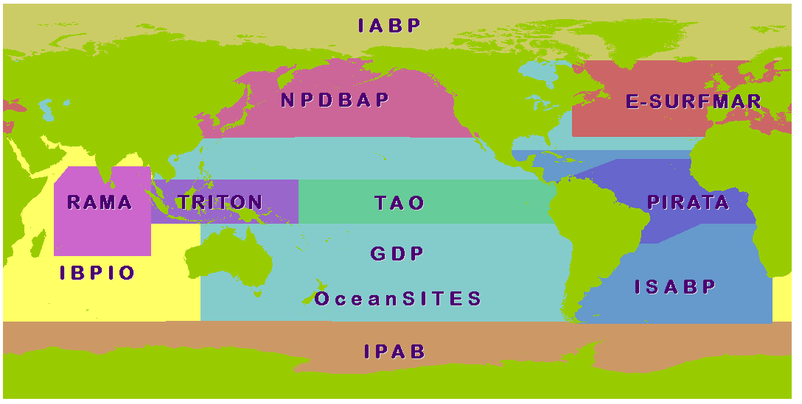

Regional Action Groups:  E-SURFMAR: EUCOS Surface Marine Programme  IABP: International Arctic Buoy Programme  IBPIO: International Buoy Programme for the Indian Ocean | IPAB: WCRP-SCAR International Programme for Antarctic Buoys  ISABP: International South Atlantic Buoy Programme  NPDBAP: DBCP-PICES North Pacific Data Buoy Advisory Panel (North 30°N)  TIP: Tropical Moored Buoy Implementation Panel (includes PIRATA and TAO/TRITON Arrays)
Global Action Groups (not shown on the map):
GDP: Global Drifter Programme
OceanSITES: Global deep ocean time-series reference stations

Figure 1: DBCP Action Groups in 2016.

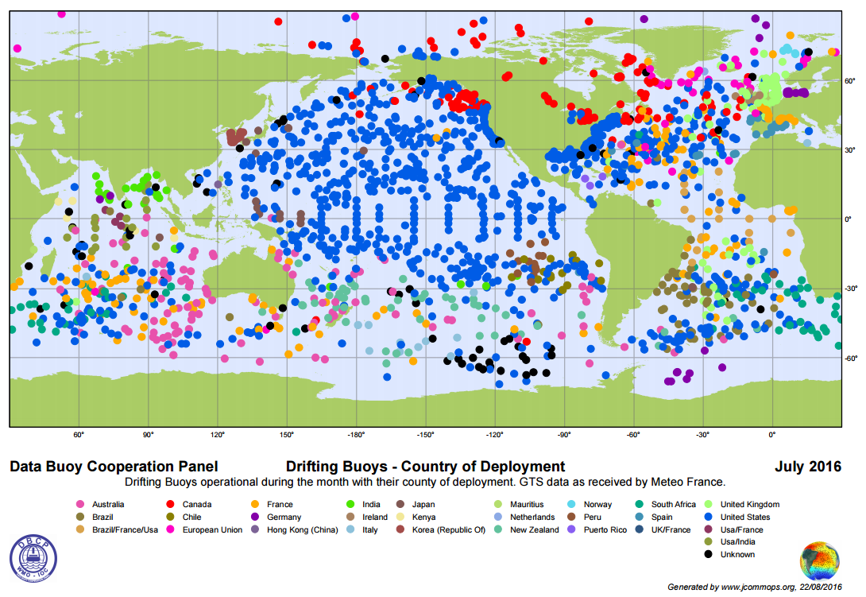

Figure 2: The Global Drifter Array in July 2016
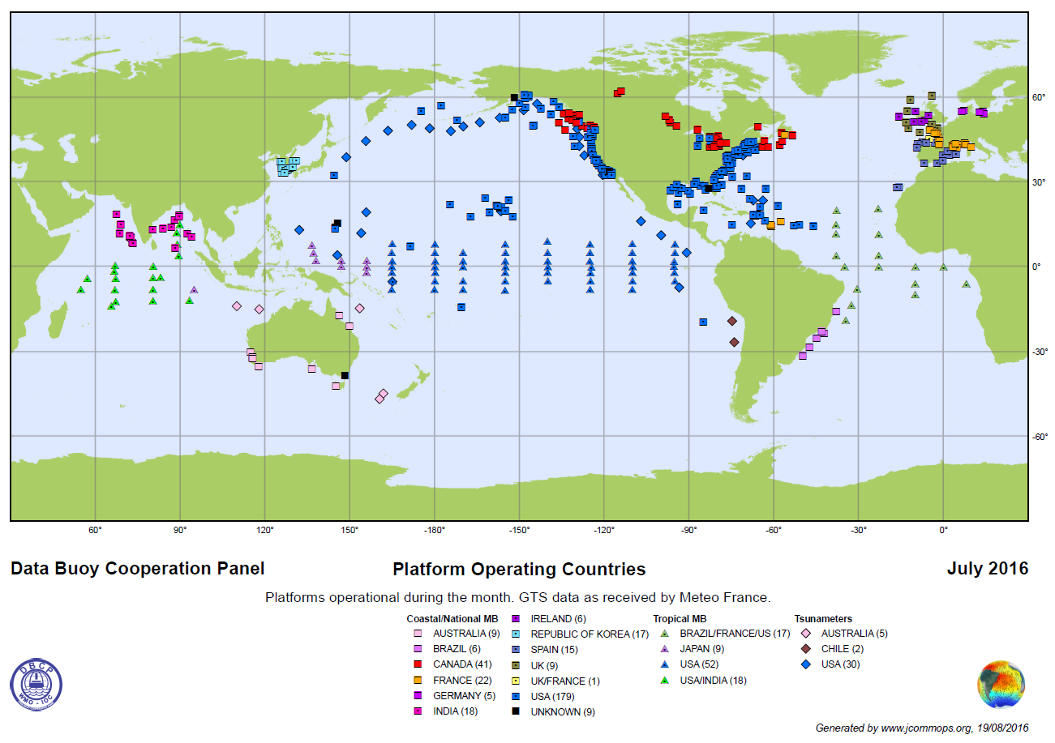
Figure 3. Over 400 operating moored buoys from various global (OceanSITES), regional (TAO/TRITON, PIRATA, RAMA) and national networks, July 2016.
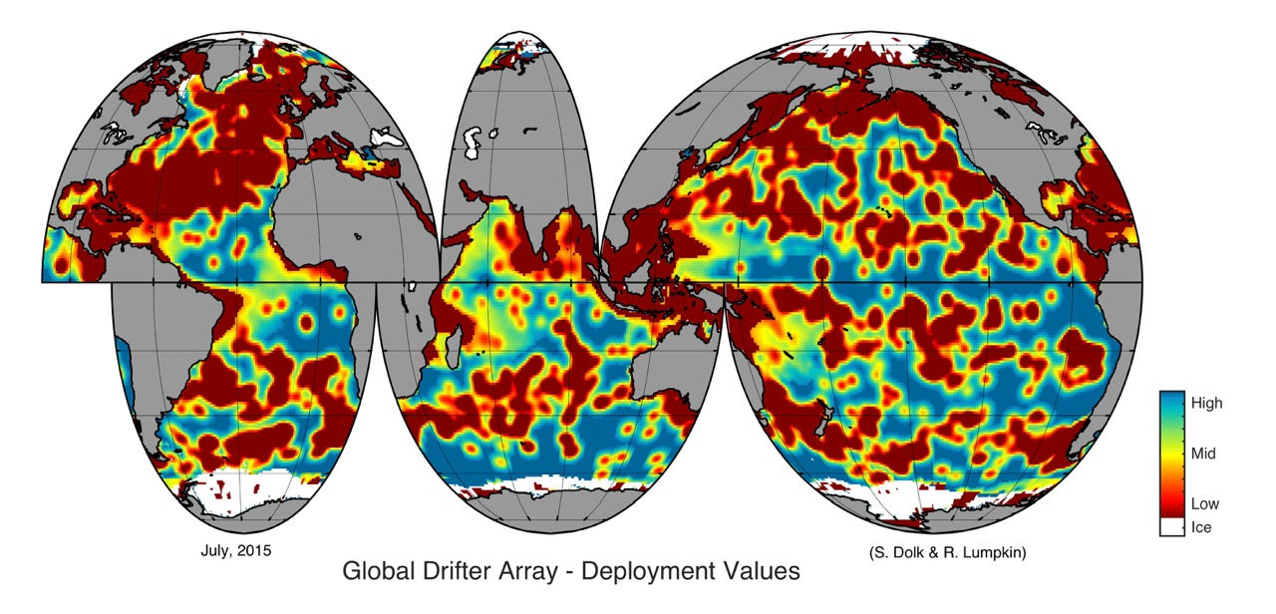

Figure 4. Map showing the most valuable areas for difter deployments in July 2015, by courtesy of the Global Drifter Center, NOAA-AOML.

Figure 5. Structure of JCOMM.

ANNEX A

Acronyms

AOML NOAA Atlantic Oceanographic and Meteorological Laboratory (USA)
ASAP Automated Shipboard Aerological Programme
CB Capacity-Building
CBS WMO Commission for Basic Systems
Cg WMO Congress
CLIVAR Climate Variability and Predictability (WCRP)
CLS Collecte Localisation Satellites (France)
CMM Centre de Météorologie Marine (Météo-France)
COST European Cooperation in the field of Scientific and Technical Research
DAC Data Assembly Center (of the WOCE Surface Velocity Programme)
DBCP WMO-IOC Data Buoy Cooperation Panel
EC Executive Council (of WMO or IOC as appropriate)
ECMWF European Centre for Medium-range Weather Forecasts
EGOS European Group on Ocean Stations (a former DBCP Action Group now merged into E-SURFMAR)
E-SURFMAR Surface Marine programme of the Network of European Meteorological Services, EUMETNET (a DBCP Action Group)
ETWS JCOMM Expert Team on Wind Waves and Storm Surges
EUMETNET The Network of European Meteorological Services
FGGE First Global GARP Experiment
GARP Global Atmospheric Research Programme
GCOS WMO-IOC-UNEP-ICSU Global Climate Observing System
GDC Global Drifter Center (of the GDP)
GDP Global Drifter Programme (a DBCP Action Group)
GEO Group on Earth Observation
GFCS Global Framework for Climate Services
GLOSS JCOMM Global Sea Level Observing System
GOOS WMO-IOC-UNEP-ICSU Global Ocean Observing System
GTS Global Telecommunication System
IABP International Arctic Buoy Programme (a DBCP Action Group)
IBPIO International Buoy Programme in the Indian Ocean (a DBCP Action Group)
ICOADS International Comprehensive Ocean-Atmosphere Data Set
IOC Intergovernmental Oceanographic Commission (of UNESCO)
IODE International Oceanographic Data and Information Exchange (of IOC)
IPAB WCRP-SCAR International Programme for Antarctic Buoys (a DBCP Action Group)
IPCC Intergovernmental Panel on Climate Change
ISABP International South Atlantic Buoy Programme (a DBCP Action Group)
ISDM Integrated Science Data Management (Canada, formerly MEDS)
ITP International Tsunameter Partnership
JCOMM Joint WMO-IOC Technical Commission for Oceanography and Marine Meteorology
JCOMMOPS JCOMM in situ Observations Programme Support Centre
JTA Argos Joint Tariff Agreement
LUT Local User Terminal
MEDS Marine Environmental Data Service (Canada, now ISDM)
META-T JCOMM Water Temperature instrument/platform Metadata Pilot Project
NDBC NOAA National Data Buoy Center (USA)
NOAA National Oceanographic and Atmospheric Administration (USA)
NOS NOAA National Ocean Service (USA)
NPDBAP DBCP-PICES North Pacific Data Buoy Advisory Panel (a DBCP Action Group)
NWP Numerical Weather Prediction
OceanSITES OCEAN Sustained Interdisciplinary Timeseries Environment Observation System (a DBCP Action Group)
OCG JCOMM Observations Coordination Group
OCO Office of Climate Observation (USA)
ODAS Ocean Data Acquisition System
OOPC GOOS-GCOS-WCRP Ocean Observations Panel for Climate
OOSDP Ocean Observing System Development Panel
OSCAR Observing Systems Capability Analysis and Review Tool
PICES North Pacific Marine Science Organization
PIRATA Pilot Research Moored Array in the Tropical Atlantic (of TIP)
PMO Port Meteorological Officer
PMT Platform Messaging Transceivers (Argos)
PTT Platform Transmitter Terminal (Argos)
RNODC IODE Responsible National Oceanographic Data Center (operated by ISDM, Canada)
ROC Unique Responsible Organization representing a Country or a group of Countries (in the Argos JTA framework as of JTA-XXVII)
SCAR Scientific Committee on Antarctic Research
SOBP DBCP Southern Ocean Buoy Programme
SOOP JCOMM Ship Of Opportunity Programme
SOC / DB JCOMM Specialized Oceanographic Centre for Drifting Buoys (operated by Météo-France)
SOT JCOMM Ship Observations Team
SST Sea Surface Temperature
SVP Surface Velocity Programme
SVP-B SVP Barometer drifter
TAO Tropical Atmosphere Ocean Array (of TIP)
TC Technical Co-ordinator (of the DBCP)
TIP Tropical moored buoy Implementation Panel (a DBCP Action Group)
TOGA Tropical Ocean Global Atmosphere Programme
TRITON Triangle Trans-Ocean buoy network (of TIP)
UNCLOS United Nations Convention on the Law of the Sea
UNFCCC United Nations Framework Convention on Climate Change
USD United States Dollar
VOS Voluntary Observing Ship Scheme
VOSClim VOS Climate Project
WCP World Climate Programme
WCRP World Climate Research Programme
WIP WIGOS Framework Implementation Plan
WIS WMO Information System
WIGOS WMO Integrated Global Observing System
WMO World Meteorological Organization
WOCE World Ocean Circulation Experiment
WWW World Weather Watch

____________

ANNEX B

Observational requirements

WMO maintained, Observing Systems Capabilities Analysis and Review tool (OSCAR) is a component of the Rolling Requirements Review process for recording observational requirements and observing capabilities (both space-based and surface-based), and conducting critical reviews of how well the capabilities address the requirements.

The observational user requirements component of OSCAR (OSCAR/Requirements) provides a record of observational user requirements formulated by WMO and co-sponsored programmes: GCOS, GOOS, WCRP. The requirements are regularly reviewed by groups of experts nominated by these organizations and programmes.

Specific requirements for the WWW, GOOS, and GCOS can be found in the WMO website:(http://www.wmo.int/oscar).

___________

ANNEX C

TECHNICAL DOCUMENTS ISSUED WITHIN THE DATA BUOY COOPERATION PANEL SERIES

No. | Title | Year of first issue | Last revision and year
1 | DBCP Annual Report for 1994 | 1995
2 | Reference Guide to the GTS Sub-system of the Argos Processing System | 1995 | Rev. 1.6, 2005
3 | Guide to Data collection and Location Services Using Service Argos | 2011 | Rev. 1, 2011
4 | WOCE Surface Velocity Programme Barometer Drifter Construction Manual | 1995 | Rev. 2.2, 2009
5 | Surface Velocity Programme Joint Workshop on SVPB drifter evaluation | 1995
6 | DBCP Annual Report for 1995 | 1996
7 | Developments in buoy technology and enabling methods (DBCP workshop, Pretoria, Oct. 1996) | 1996
8 | Guide to moored buoys and other ocean data acquisition systems | 1997
9 | DBCP Annual report for 1996 | 1997
10 | Development in buoy and communications technologies (DBCP workshop, Henley on Thames, Oct. 1996) | 1997
11 | DBCP Annual report for 1997 | 1998
12 | Developments in buoy technology and data applications (DBCP workshop, La Réunion, Oct. 97) | 1998
13 | DBCP Annual report for 1998 | 1999
14 | Variety in buoy technology and data applications (DBCP workshop, Marathon, Florida, Oct. 98) | 1999
15 | Global drifting buoy observations, A DBCP Implementation Strategy | 1999 | Rev. 14, 2016
16 | DBCP Annual Report for 1999 | 2000
17 | Developments in Moored and Drifting Buoy Design, Programmes, Sensors, and Communications (DBCP Workshop, Wellington, Oct. 1999 | 2000
18 | DBCP Annual report for 2000 | 2001
19 | Developments in buoy technology, communications, and data applications (DBCP Workshop, Victoria, Oct. 2000 | 2001
20 | DBCP Annual report for 2001 | 2002
21 | Dev. in buoy technology, communications, science and data applications(DBCP Workshop, Perth, Oct. 2001) | 2002
22 | Research, applications and developments involving data buoys(DBCP Workshop, Martinique, Oct. 2002) | 2003
23 | DBCP Annual report for 2002 | 2003
24 | Research, Applications and Developments involving data buoys (DBCP Workshop, Angra Dos Reis, Brazil, October 2003) | 2004
25 | DBCP Annual report for 2003 | 2004
26 | DBCP Annual report for 2004 | 2005
27 | DBCP Annual report for 2005 | 2006
28 | JCOMM TR No. 35. Application of collected data, Presentations at the DBCP Technical Workshop, Chennai, India, 18-19 October 2004 - Web only (web) | 2006
29 | JCOMM TR No. 37. Application of collected data, Presentations at the DBCP Technical Workshop, Buenos Aires, Argentina, 17-18 October 2005 - Web only (web) | 2006
30 | Technological Developments and Applications of Data Buoys for Tsunami Monitoring Systems, Hurricane and Storm Surge Prediction, Presentations at the DBCP Technical Workshop, La Jolla, 16-17 October 2006 – Web only (web) | 2007
31 | DBCP Annual report for 2006 | 2007
32 | Presentations at the DBCP Scientific and Technical Workshop, Jeju, Republic of Korea, 15-16 October 2007 – CD-ROM & Web only (web) | 2008
33 | DBCP Annual report for 2007 – CD-ROM & Web only (web) | 2008
33 | Annual Report for 2007 (web) | 2008
34 | Presentations made at the DBCP scientific and technical workshop, Cape Town, Republic of South Africa, 13 October 2008 (web) | 2008
35 | Annual report for 2008 (web) | 2009
36 | Presentations at the DBCP Scientific and Technical Workshop, Paris, France, 28 September 2009 (web) | 2010
37 | Guide to buoy data quality control tests to perform in real-time by a GTS data processing centre (web) | 2010
38 | Annual report for 2009 (web) | 2010
39 | Presentations at the DBCP Scientific and Technical Workshop, Oban, United Kingdom, 27 September 2010 (web) | 2011
40 | Annual report for 2010 (web) | 2011
41 | Ocean Data Buoy Vandalism - Incidence, Impact and Responses (web) | 2011
42 | Sea Surface Salinity Quality Control processes for potential use on Data Buoy observations (web) | 2011
43 | Presentations at the DBCP Scientific and Technical Workshop, Geneva, Switzerland, 26 September 2011 (web) | 2011
44 | Annual report for 2011 (web) | 2012
45 | Presentations at the DBCP Scientific and Technical Workshop, Fremantle, Australia, 2 October 2012 (web) | 2012
46 | Annual report for 2012 (web) | 2013
47 | Presentations at the DBCP Scientific and Technical Workshop, Paris, France, 23 September 2013 (web) | 2013
48 | Annual report for 2013 (web) | 2014
49 | Proceedings of the Second Capacity Building Workshop of the DBCP for the North Pacific Ocean and Its Marginal Seas (NPOMS-2), Hangzhou, China, 22-24 October 2013 (web) | 2014
50 | Proceedings of the Third Capacity Building Workshop of the DBCP for the North Pacific Ocean and Its Marginal Seas (NPOMS-3), Kyoto, Japan, 6-9 October 2014 | pending
51 | Presentations at the DBCP Scientific and Technical Workshop, Weihai, China, 27 October 2014(web) | 2014
52 | DBCP Annual Report for 2014 (web) | pending
53 | Presentations at the DBCP Scientific and Technical Workshop, Geneva, Switzerland, October 2015 (web) | 2015
54 | DBCP Annual Report for 2015 (web) | 2016
55 | Recommendations of the Fourth Capacity Building Workshop of the DBCP for the North Pacific Ocean and Its Marginal Seas (NPOMS-4), Busan, Republic of Korea, 2-4 November 2015 (web) | 2015
56 | The DBCP – A Retrospective (web) | 2016
57 | DBCP Annual Report for 2016 (web) | 2016
58 | Outreach Strategy to Reduce Damage to Ocean Data Buoys From Vandalism | 2017
59 | DBCP Annual Report for 2017(web) | 2017
60 | 3rd Pacific Islands Training Workshop on Ocean Observations and Data Applications (DBCP-PI-3) and 5th JCOMM Marine Instrument Workshop for Asia-Pacific Region (RMIC/AP-5), Xiuying District, Haikou, Hainan Province, China, 09-12 July 2018 | 2018

Web site: http://www.wmo.int/pages/prog/amp/mmop/dbcp_reports.html
These publications can also be ordered from: Technical Co-ordinator of the DBCP, JCOMMOPS, 8-10 rue Hermès, Parc Technologique du Canal, F-31526 RAMONVILLE SAINT-AGNE, France – E- mail: support@jcommops.org – Telefax: +33 5 61 75 10 14
___________

[page left intentionally blank]

https://www.wmo-sat.info/oscar/
http://www.wmo.int/pages/prog/www/OSY/RRR-DB.html
https://www.wmo-sat.info/oscar/variables/view/134
Annex A ∗ Here we use term ‘operational’ as meaning observational activities that are undertaken according to agreed standards on a routine and on-going basis with plans in place for continuity and homogeneity. This includes sustained observations funded through research budgets.
http://www.jcommops.org/dbcp/doc/DBCP_Operating-Principles.pdf
∗ JCOMM-IV approved establishment of the National Marine Data and Information Service (NMDIS) of the China State Oceanic Administration (SOA) in Tianjin and the Deutscher Wetterdienst (DWD) in Hamburg to act as CMOCs on a trial basis.
* ER-4: Enhanced capabilities of Members to access, develop, implement and use integrated and interoperable Earth- and space-based observation systems for weather, climate and hydrological observations, as well as related environmental and space weather observations, based on world standards set by WMO.
∗ http://www.wmo.int/pages/prog/www/wigos/documents/Principal_Docs/WIP_en_v.2.0_APP_EC-65_en.doc
∗ http://www.wmo.int/wigos/wir

